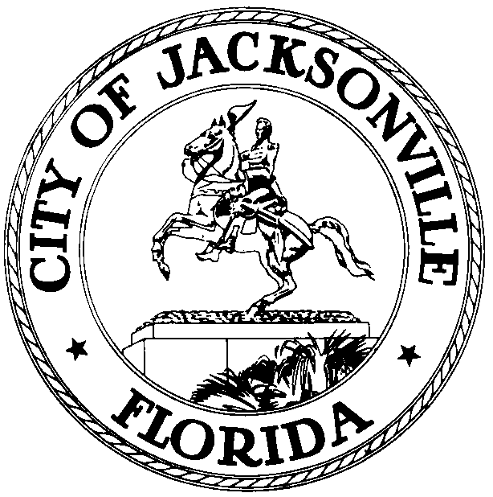
OFFICE OF THE CITY COUNCIL
JOHN CRESCIMBENI  COUNCIL MEMBER, AL-GROUP 2  OFFICE (904) 630-1381  FAX (904) 630-2906  E-MAIL: JRC@coj.net |  | 117 WEST DUVAL STREET  SUITE 425  JACKSONVILLE, FLORIDA  32202

May 6, 2016
(1:00 p.m.)

MEETING NOTICE

TO: Special Economics Development Incentives Committee Members

Honorable Council President Greg Anderson
Honorable Council Member Anna Lopez Brosche
Honorable Council Member Katrina Brown
Honorable Council member Matt Schellenberg

FROM: The Honorable John R. Crescimbeni
Chairman, Special Economics Development Incentives Committee

SUBJECT: 05.20.16 Special Economics Development Incentives Committee Meeting

Notice is hereby given that Council Member John Crescimbeni, Chair of the Special Economic Development Incentives Committee will meet with Committee Members on Friday, May 20 th , 2016 at 9:00 a.m., in Conference Room A, 4th Floor, Suite 425 – City Hall, 117 West Duval Street, Jacksonville, Florida, 32202.

This meeting is open to the public and all interested parties are welcome to attend. Please mark your calendars accordingly. Please contact Jessica B. Morales, Legislative Assistant, at (904) 630-1404, for additional information or correspondence.

JC/jm

cc: Council Members/Staff
Cheryl Brown, Director
Dana Farris, Chief, Legislative Services Division
Carol Owens, Assistant Chief, Legislative Services Division
Jeff Clements, Chief of Research
Kirk Sherman, Council Auditor
Office of the General Counsel
CityC@coj.net
Posted Meeting – City Council Calendar
Electronic Notification – 1st Floor City Hall
Posting to Public Notices – City Council Web Page

Media Box
File Copy

